2D puzzle game

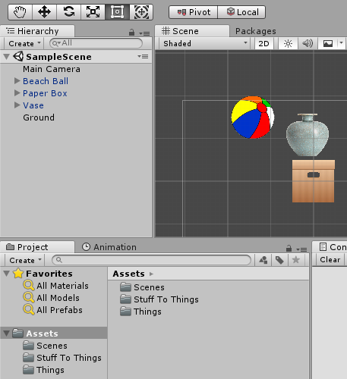

Different items have different properties. Example: The ball pops when pressed. The finished game would have many levels with puzzles where you would have to navigate when to press the different items with different strategic uses.

Balance Game

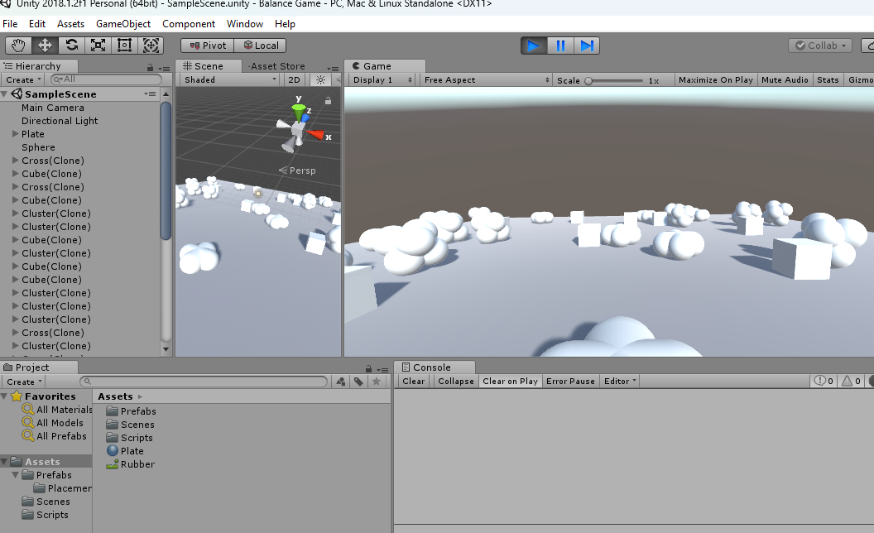

Intended to be a turn-based game where you press each item on the platform to remove it. Each player would try to make sure that the platform does not fall down while doing so.

Ballon Runner

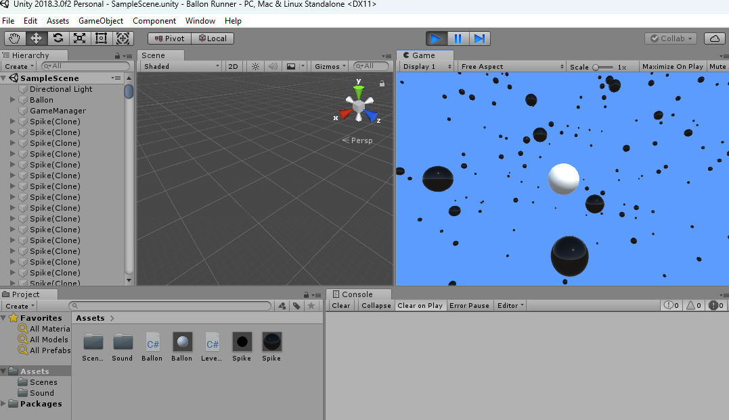

A game with a lot of funny sounds. Press space to make the white ball jump closer to the camera. The camera moves along and the white ball works as a flappy bird. Try to avoid the black balls, I guess.

Biltur Til Explore

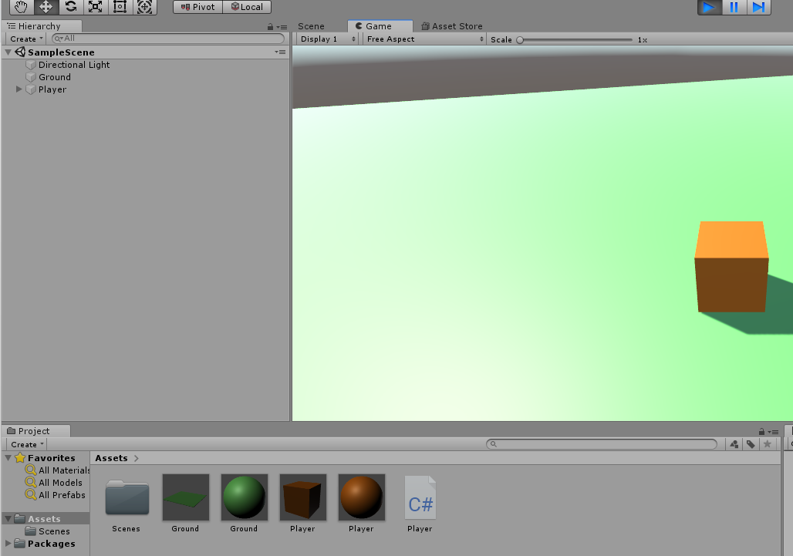

You can steer the orange player cube around with the arrow keys.

BlodEscape

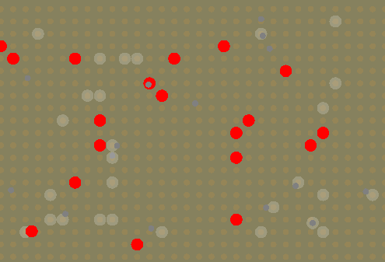

The game spawns blood cells that you are supposed to avoid. Was supposed to be a successor to the previous BloodEscape game but with more advanced mechanics. This does not work as a game yet and is just spawning obstacles when pressing play.

Board Game Timer

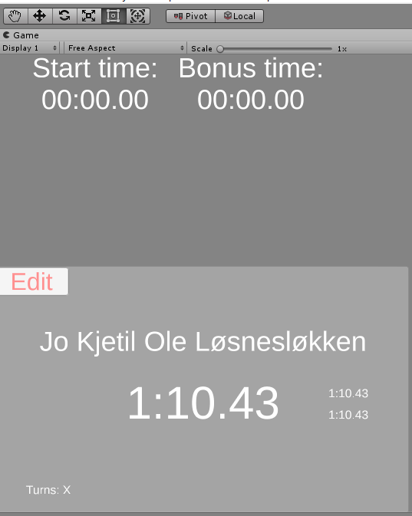

Was supposed to be a timer that could have as many players as you wish and keep track of the time left on each player. I could not figure out how to start the timer or anything.

BombExplotion

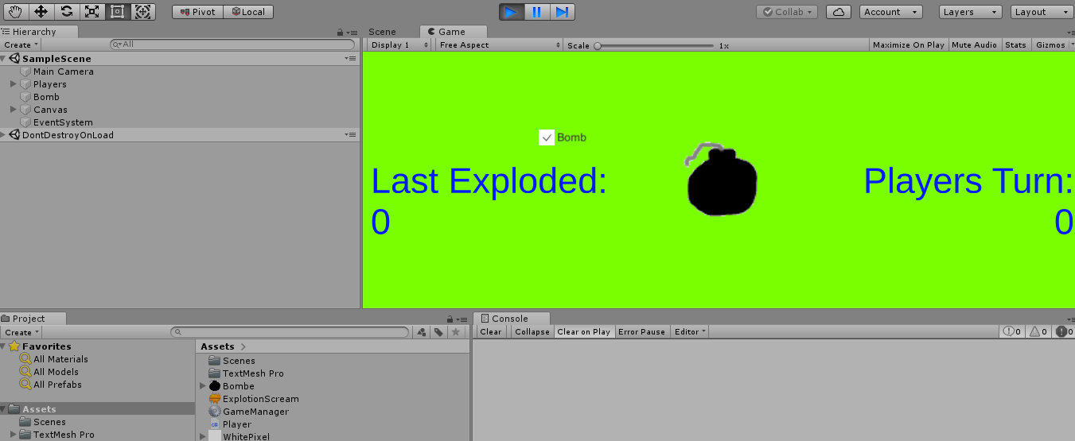

BombPuzzle

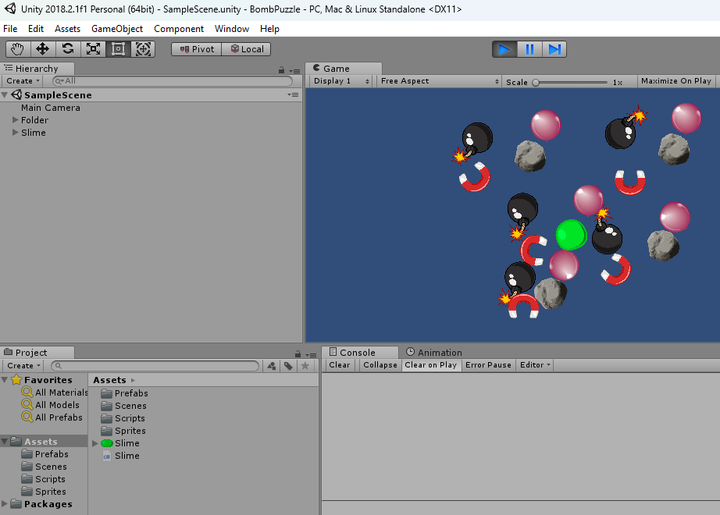

Press the different items to win the game. The **bomb** pushes everything away from it. The **magnet** draws things closer to them. The **purple bubble** pops when pressed. The **green slime** attaches to things when it touches things. The **rock**, I think does nothing? The game probably intended to have different levels to complete.

Bounchy Ball

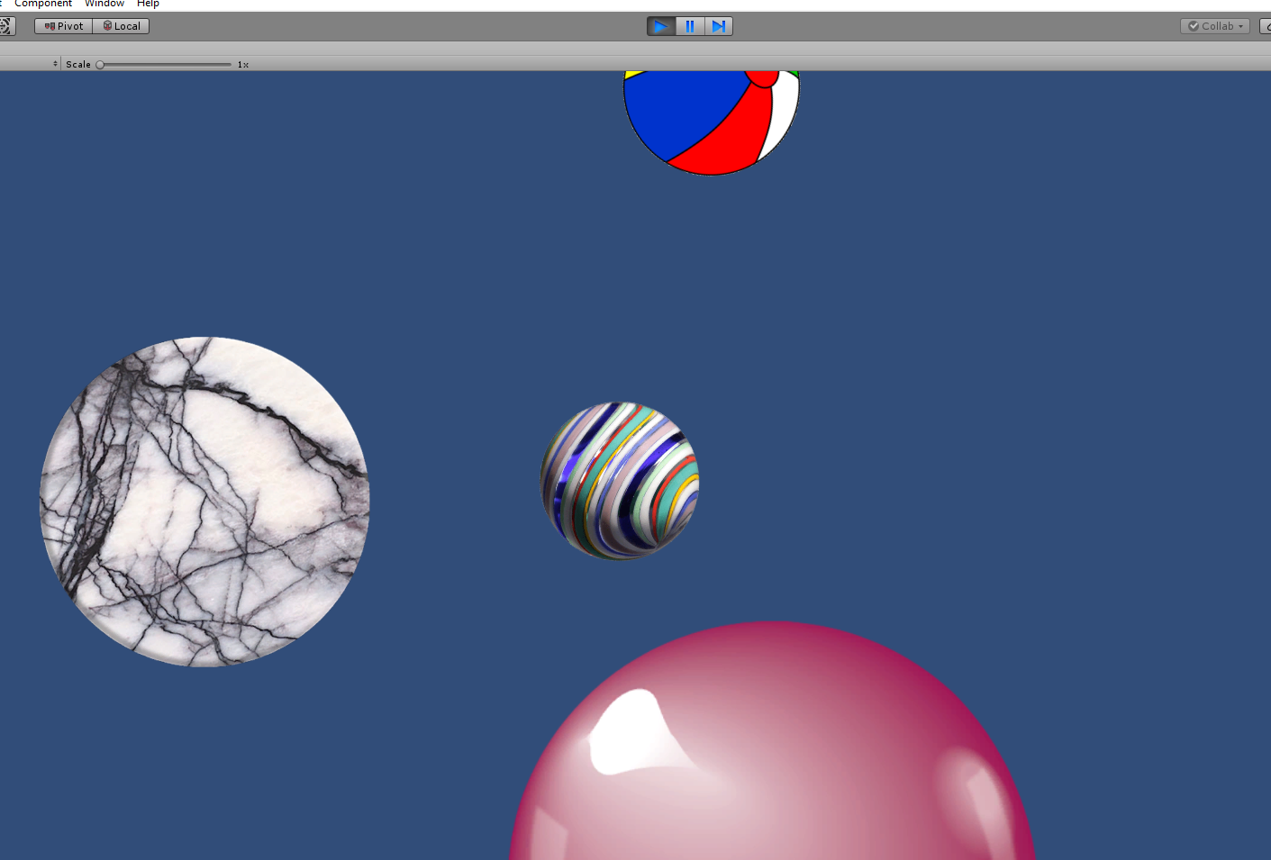

You control the purple ball and try to keep the other balls on the screen while they bounce up and down.

Clicker

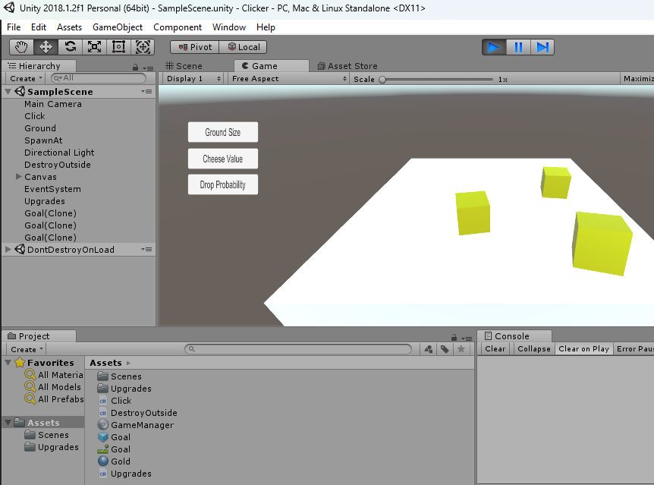

Try to make the bouncy cheese stay on the platform when falling. Upgrade size of the ground and how often they drop as well as how much the cheese is worth.

Colektiv Flappy Bird Kahoot Ting

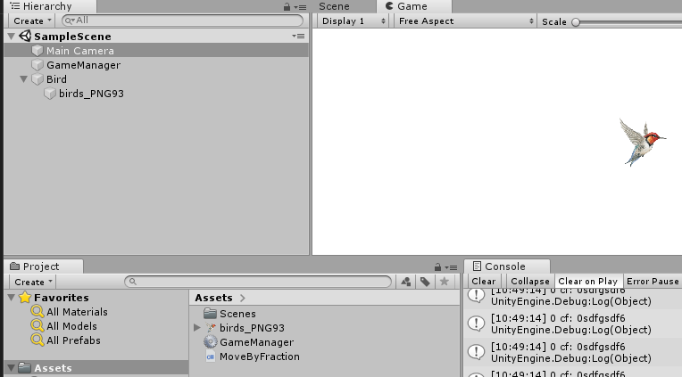

I could not be able to move the bird, but the intention probably was to connect smartphones to the screen, and be able to connect with a code so that peoples watching the same screen could control the bird and avoid the obstacles.

Corona Virus

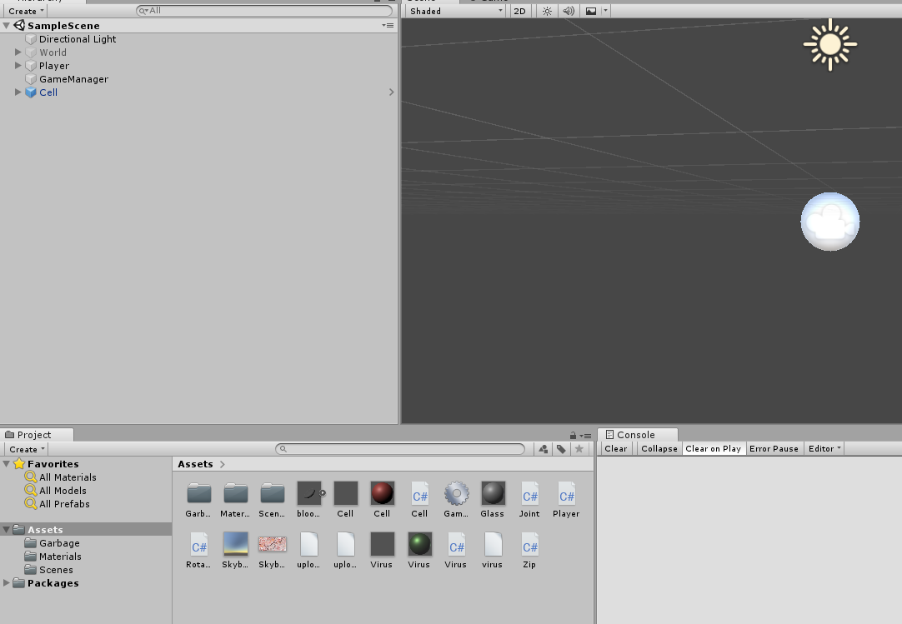

3d game from 1 person perspective where you can turn around. The objective looks like was intended to be exploring the body from the perspective of a cell or virus in that body, trying to protect cells. But the game does not work at all.

Dice App

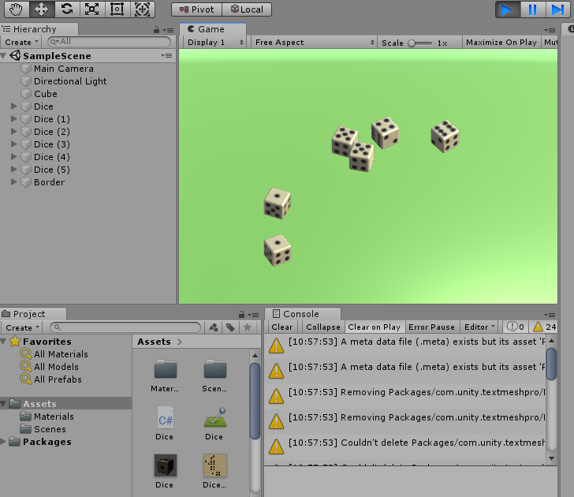

Rolls when pressing space. It works much better than expected. The dice are trown into the air and a random outcome is produced by physics like real dice. The dice does not detect the roll number yet, but if it did and the app was completed, it would be an cool app with cool real rolling animation.

DriveMadness

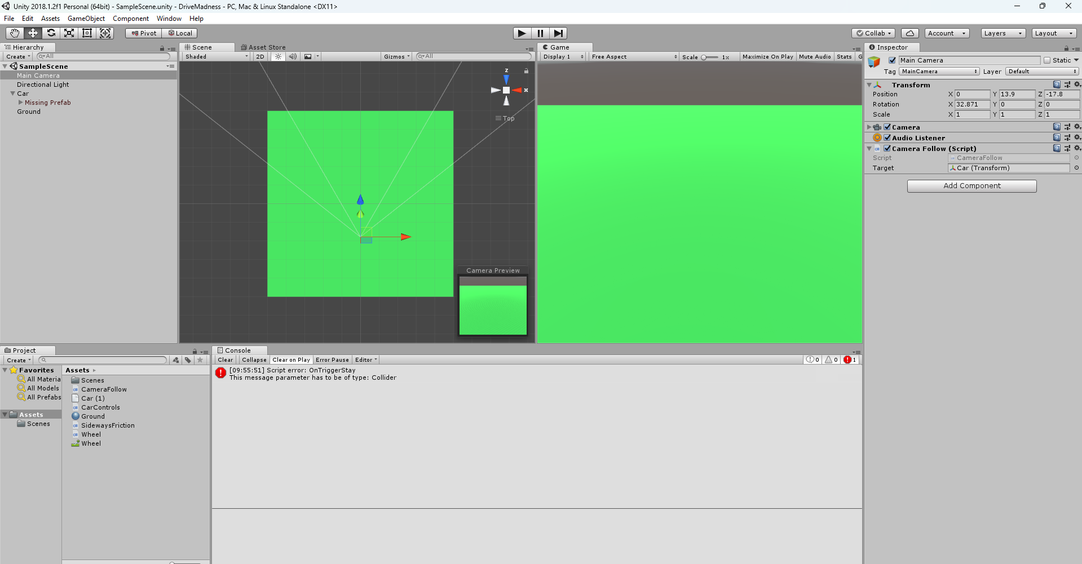

Easy

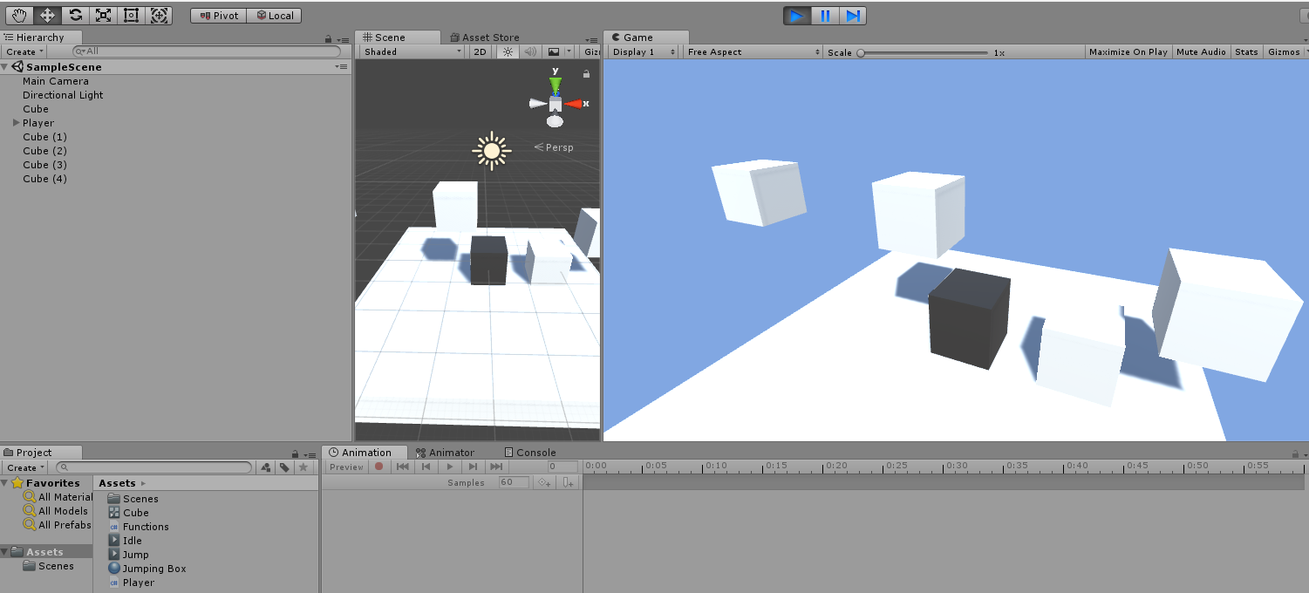

Jump around with the grey cute creature with animations like breathing and jumping etc.

Easy Multy Shoot Circle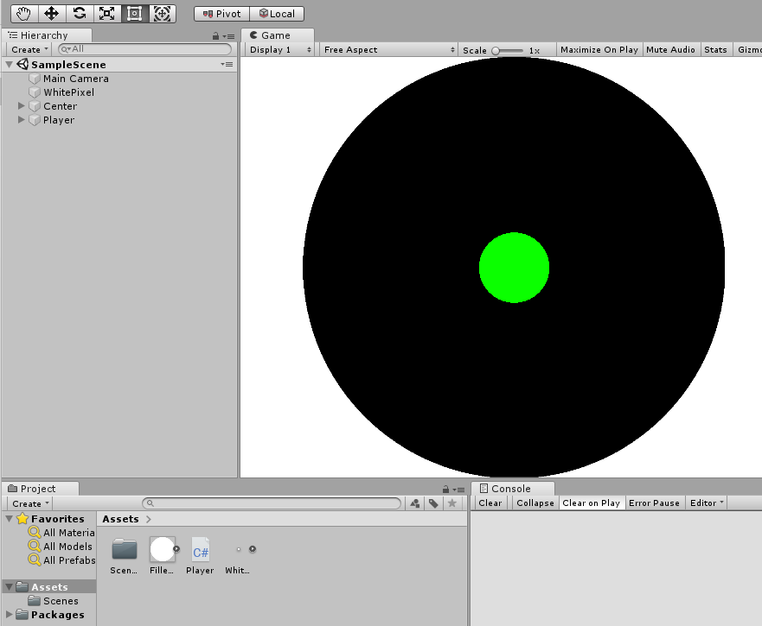

I was not able to figure out what this project was. I don’t think it has any functionality, just a little script with does not seem to do much.

Flerspiller Halvor

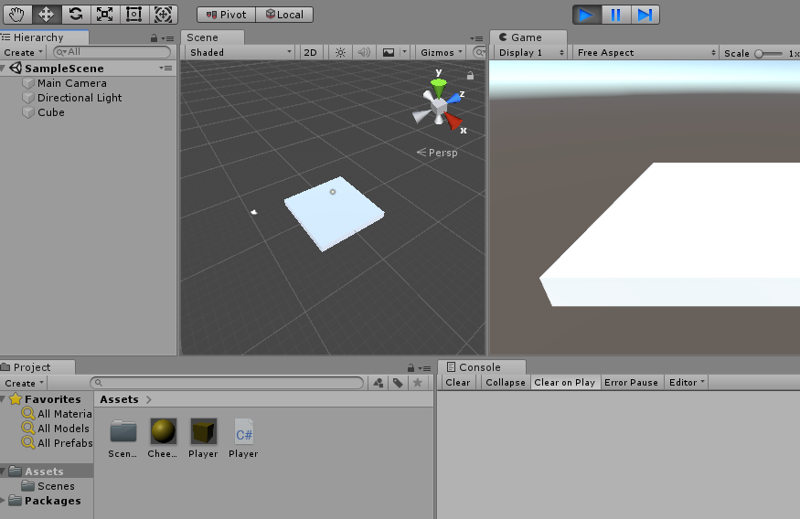

This game seems to do nothing.

FlyPlane

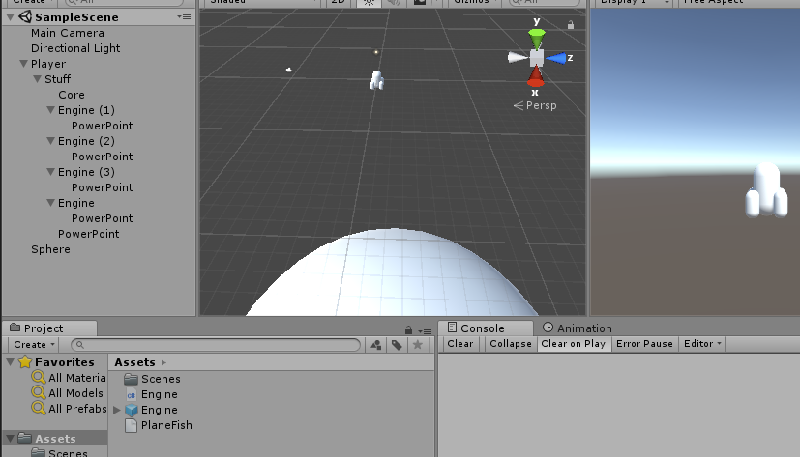

The intended meaning for the game was to make possible for the player to create his own flying machine and attach engines that you would be able to control individually. This game seems to do nothing right now.

Foundation Drop

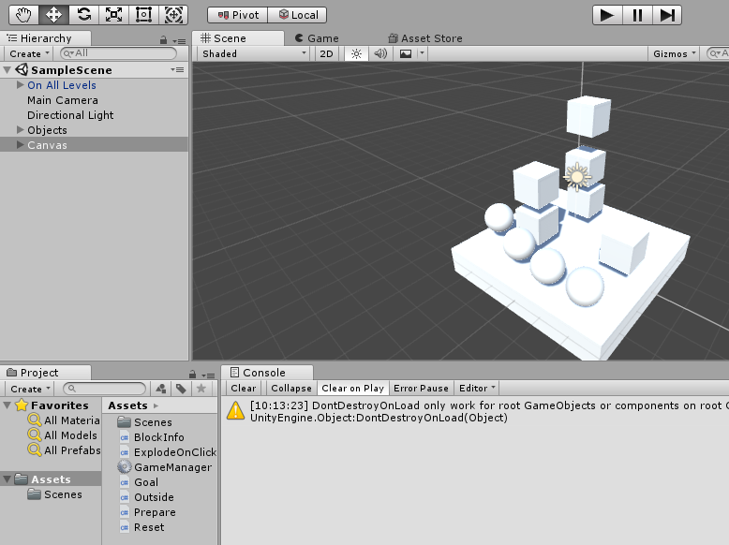

Frisky Box

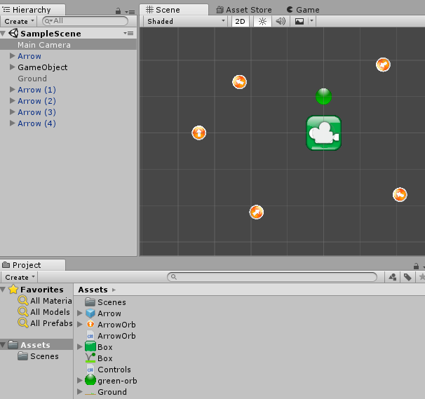

Jump and spin around while you try to hit the orange arrows while doing so. Just control the player with one button. Make the green dot that spins around the player hit the orange items floating around.

Funny Game Hos Ole Jakob

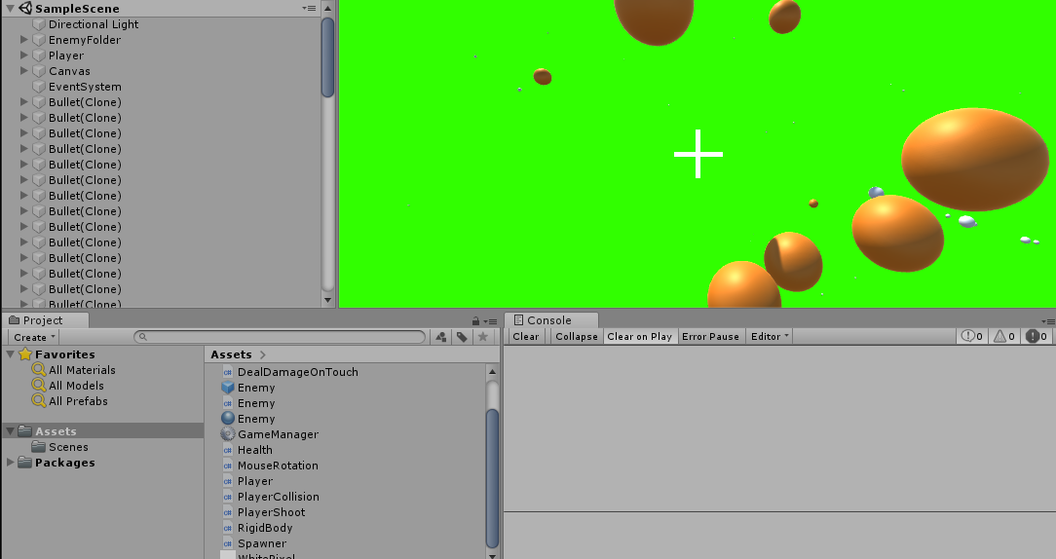

Shoot the orange things coming towards you from all 360 degrees around you. You shoot white bullets and make sure to survive as long as you are able!

Game in 3 hours

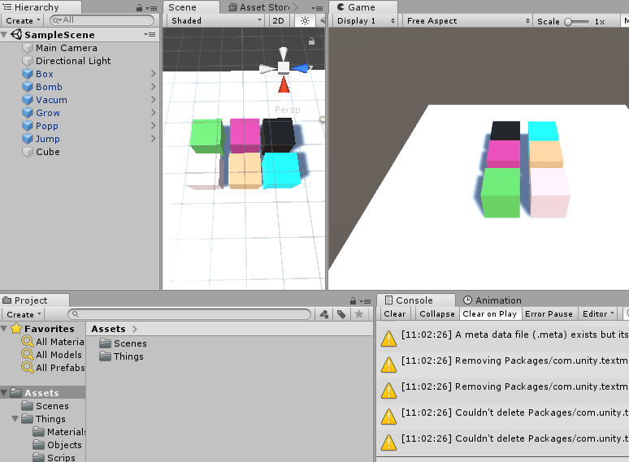

This game seems to experiment with different items doing different things. The different colors do different things when pressed. Blue jumps, White is destroyed, purple pulls things like a magnet, black pushes things with an outward force like a bomb, green grows when pressed, etc. The intention was probably to have levels to complete so that you had to press the items strategically.

Golf

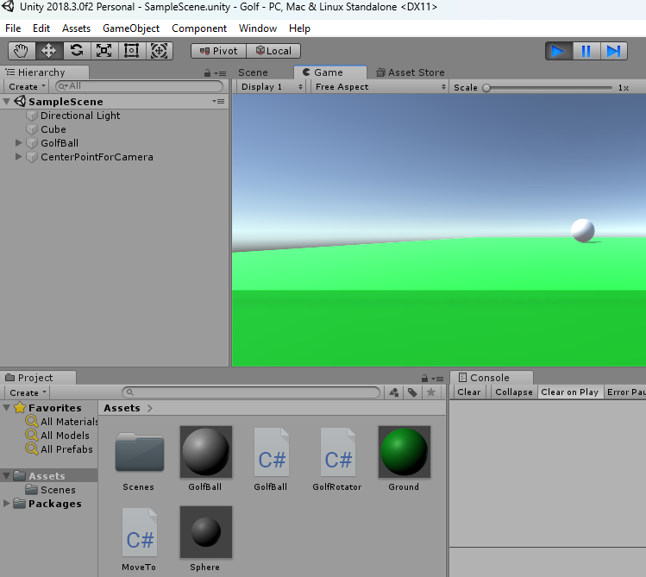

Were supposed to be a golf game. Currently the white ball just jumps when holding the spacebar to adjust for different amount of force.

Gravitational Pull

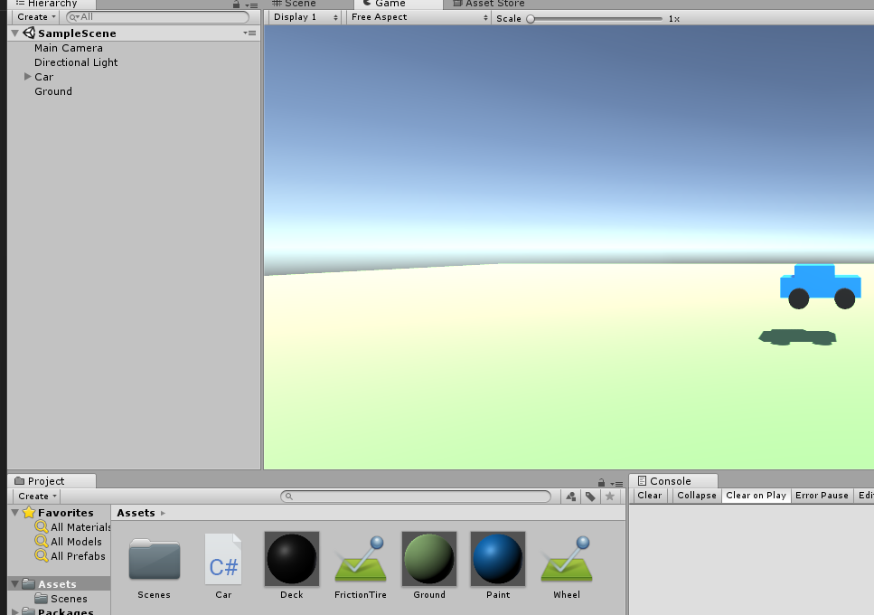

Control the blue cute car around on the ground.

Happy Blob Bounching 2



A working game where the yellow player wants to jump to the other red platform without touching the white. Hold space to charge up the jump and let go of space when you want to jump. Are you able to aim at the other platform? When you jump the platform was standing on moves and you jump the other way the next time.

Jump

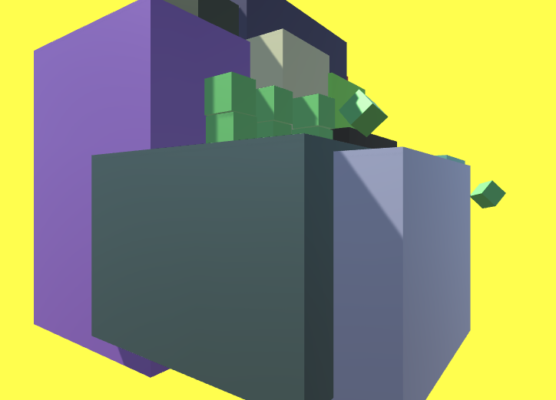

You don’t jump in this game even though the name suggests so. You press the different cubes and try to break them by clicking. When a block is broken it drops into many smaller blocks and disappears. A fun experiment with cool animations.

Karl Ivar

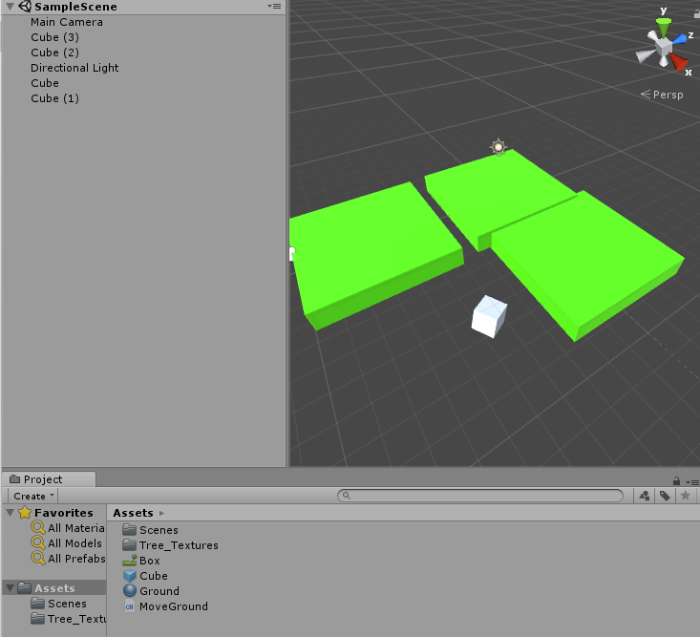

Nothing much, but platforms move up and down.

Koding hos Adrian

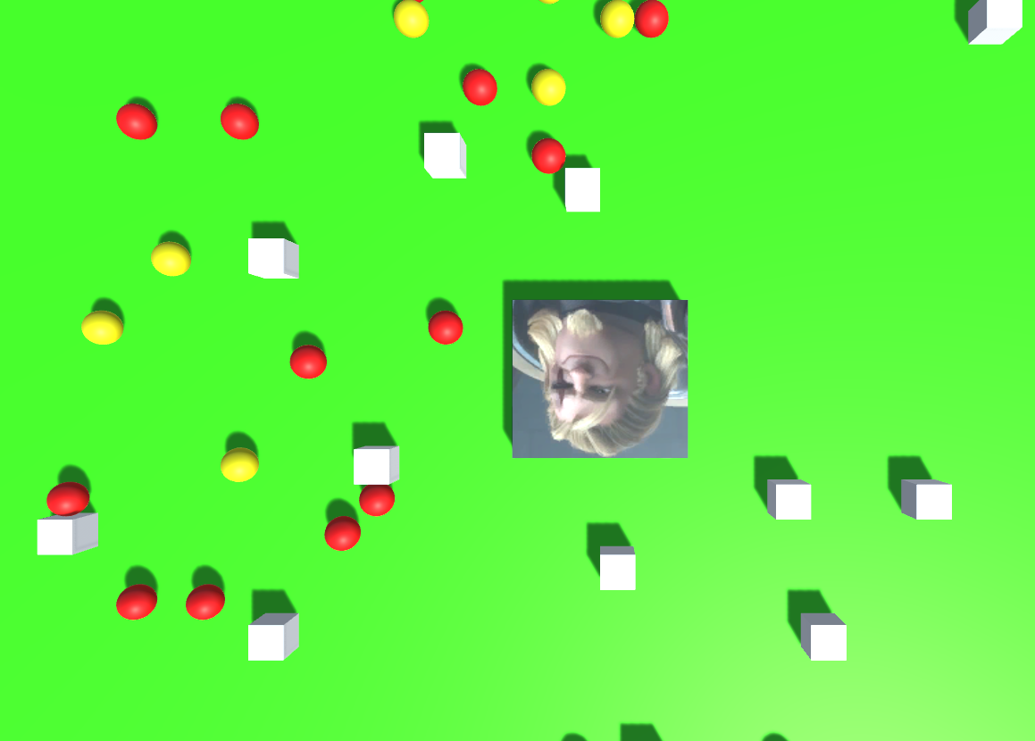

Move around. Change size when eating the red and yellow dots.

Konfirmant Foreldrefest



A working program that reveals only part of the image at a time. Make people go on different teams and guess what is behind the image before the other teams. If has different game modes. 1. Guess it first with automatic random opening of squares. 2. Or each team selects your their own squares and takes their time to guess on their turn.

KonkuranselNK

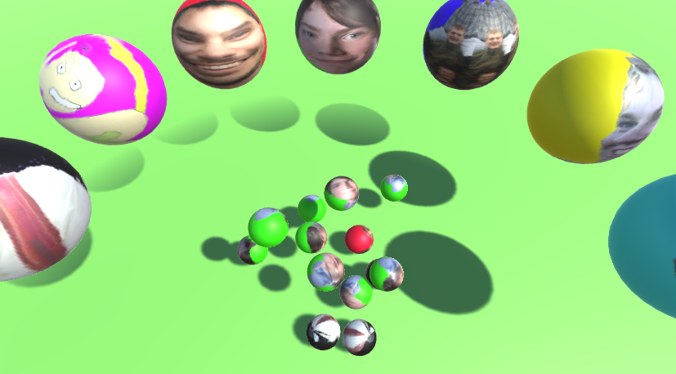

Press the different heads to give score to that team and fill up the bowl with the color of your team to win. Just a scoring system made for a competition evening with the youth group that I lead.

Lære Anne Margrete Å Kode

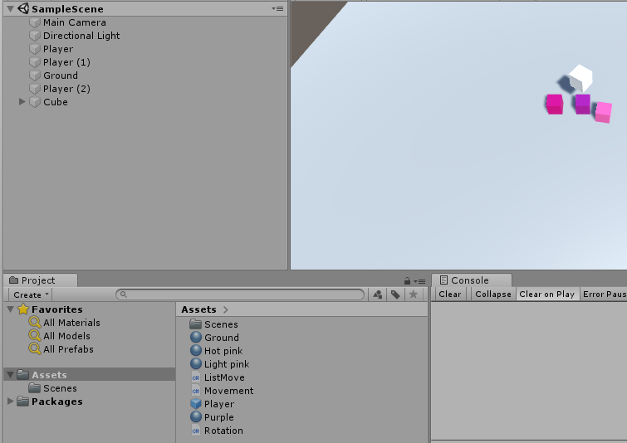

Things seem to be spinning around etc., but it does not seem to be doing much.

Lære Elias

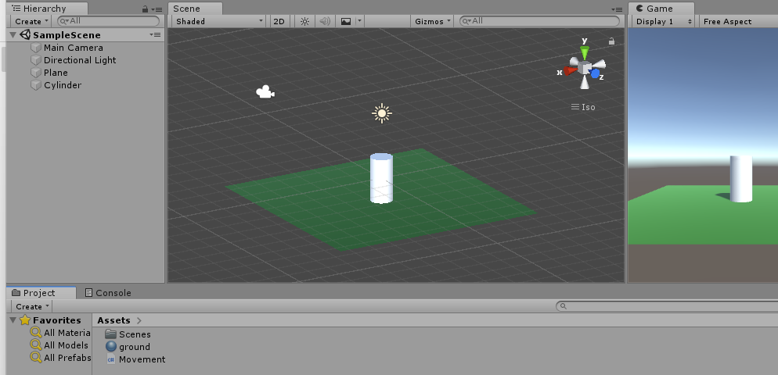

Does not look like much. But the white thing jumps when pressing space. It has some king of ground detection.

Learn Multiplayer Unity

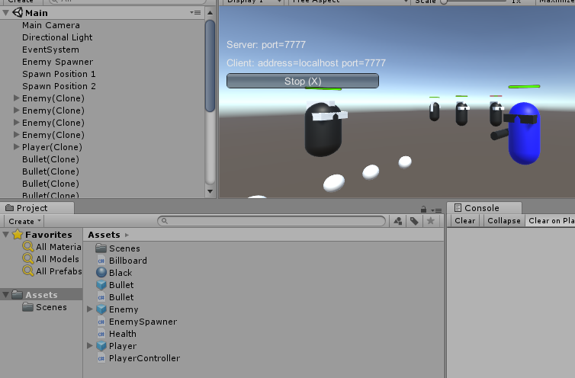

Move around and shoot.

Litle Dot

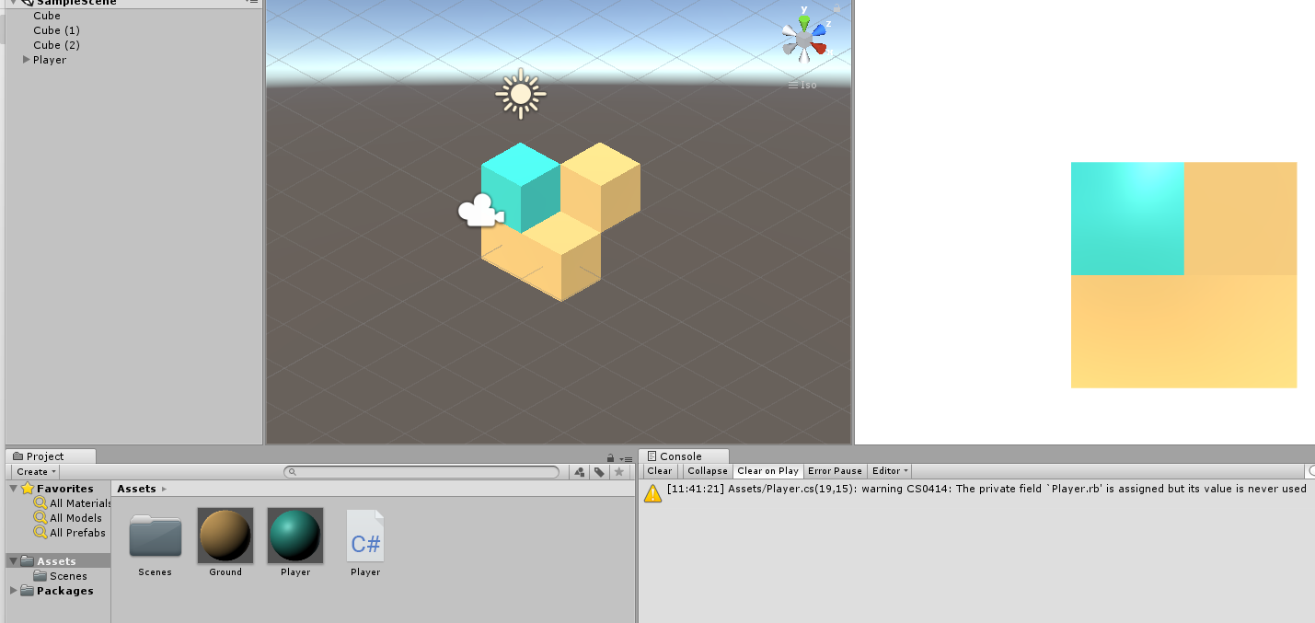

Move around with the arrow keys and transform the level by rotating the entire level with the wasd keys. You are only able to see the level from one angle at the time.

Meshes With Script

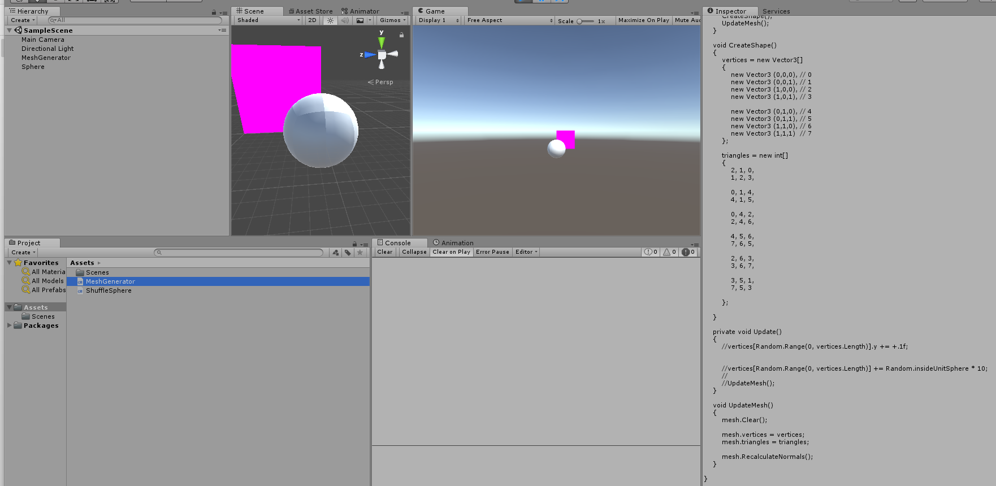

I think this was an experiment on how to generate Meshes using script and plotting out each point on each triangle in 3D space.

Miljøhelg

Could not open project, but this was created for an escape room I created to be able to write in codes and revel some text of other code by the input. You could change a file to choose what input should create what output.

MiningGame

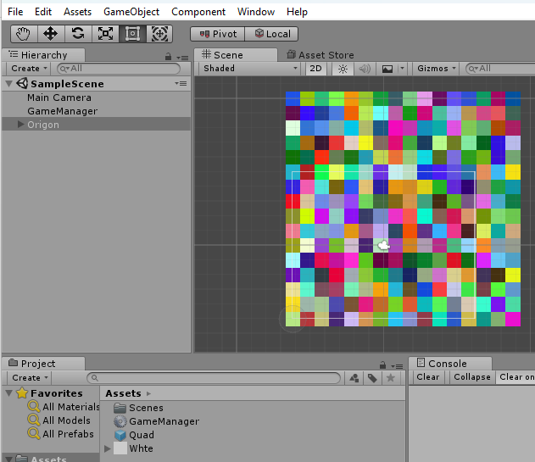

Generates a random level that probably was supposed to be mineable by a player at some point. The colors would probably be replaced with sprites.

Mouse

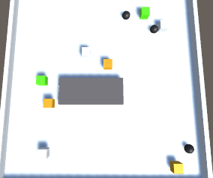

You control a mouse, the gray player there, and try to eat all the cheese while avoiding the black bombs. When eating cheese you change to a random size.

Music Program Teach To Read Sheet Music Fast

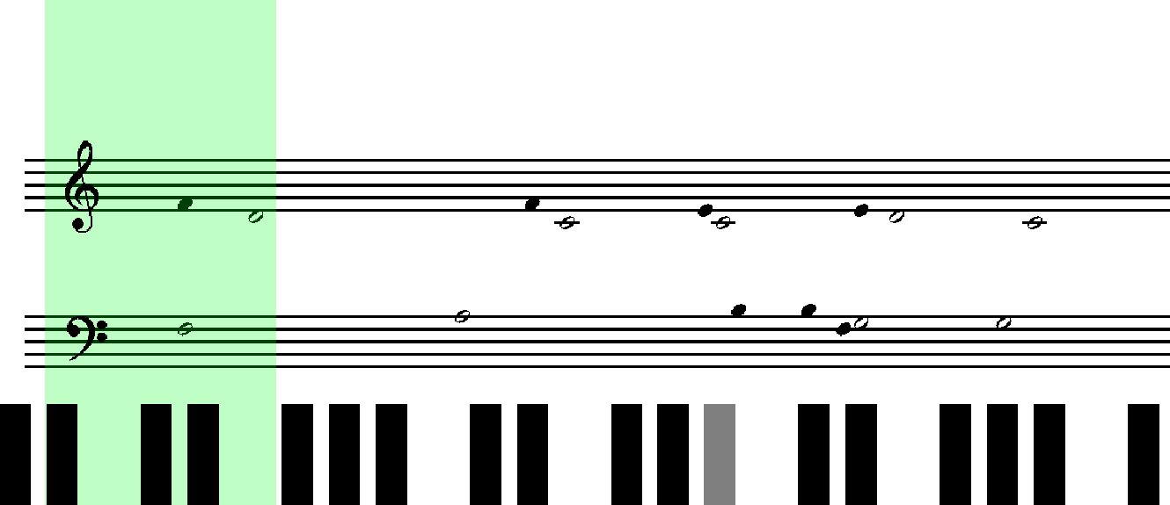

Seems to be the first version of my sightreading program.

New Unity Project

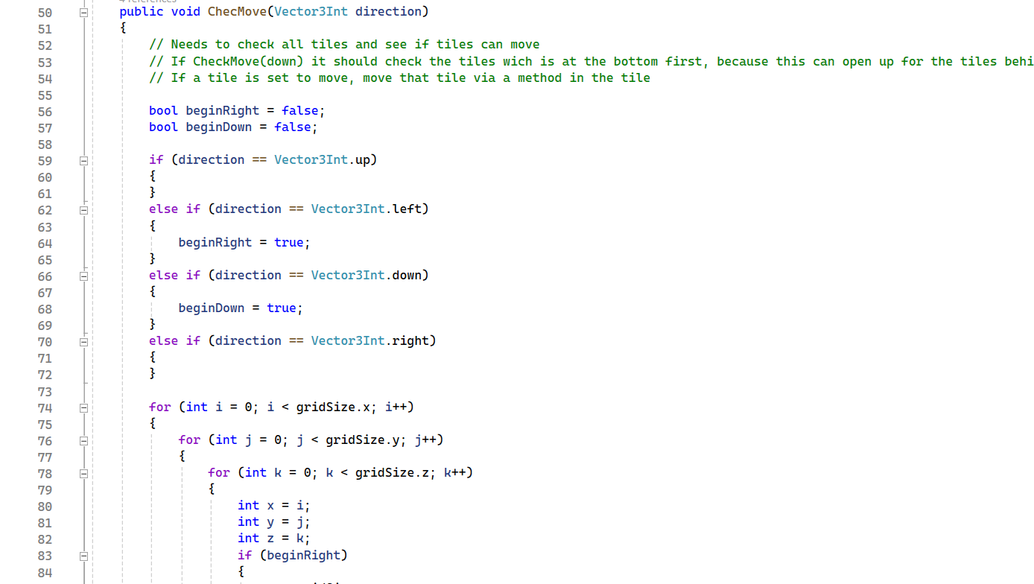

Has an interesting script but I am not able to see anything actually produced when I look at the actual running game. Just seems blank with no functionality. Might need to connect with a gaming controller to work? Seems like the script is supposed to generate some kind of level.

New Unity Project (1)

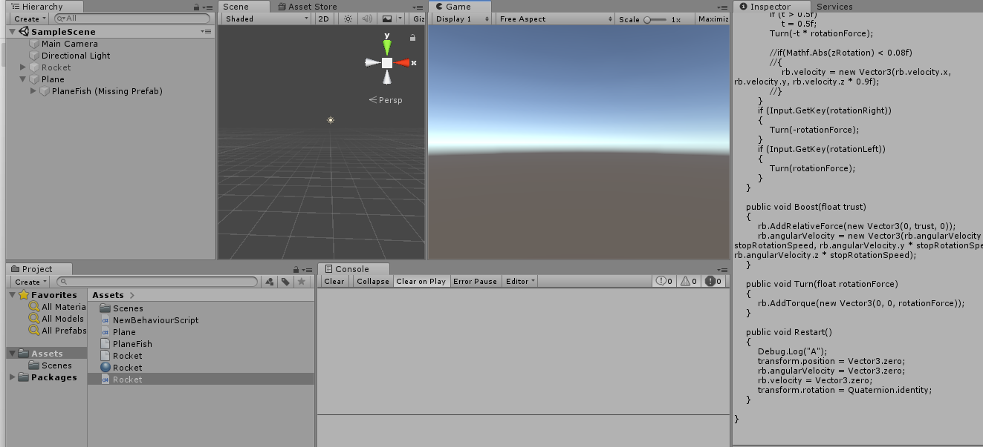

Some kind of flying games. The meshes seem to be missing and are probably only on my old computer. So, it is not possible to see the actual game if it were to work.

Notatius

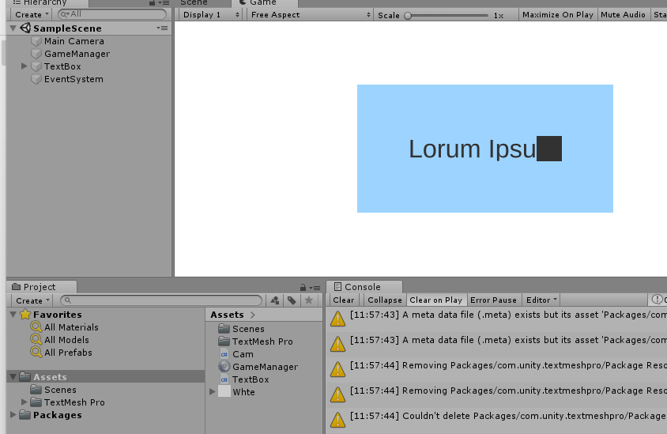

You can write in the text box. The goal was to create an application so that you could note and create boxes and connect them to each other and create some kind of mind map in an interesting way. For now it is just a text box that you can type in, and a blank paper that you can move infinitely around in. Mabey it has more functionality that I did not find while testing.

Perlin Noise



A level is generated with Perlin noise. The red ball’s position directly affects where the yellow ball is. And the black points are where the red ball would collide with the yellow ball. The Green are spaces where the yellow ball is avoided. It uses Perlin noise to find out the position on the yellow ball based on the red one. Move the red ball around with your mouse.

Physics Puzzle

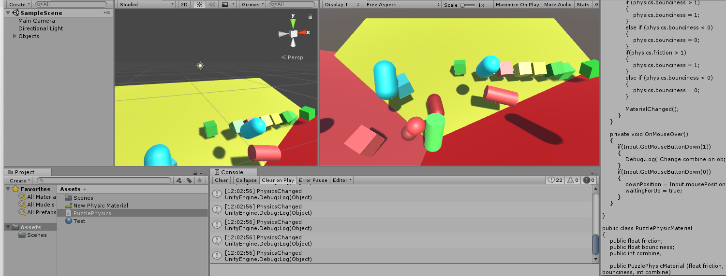

Seemed very interesting, but I were not able to remember what this was, or how to interact with the game.

PuzzleBlock

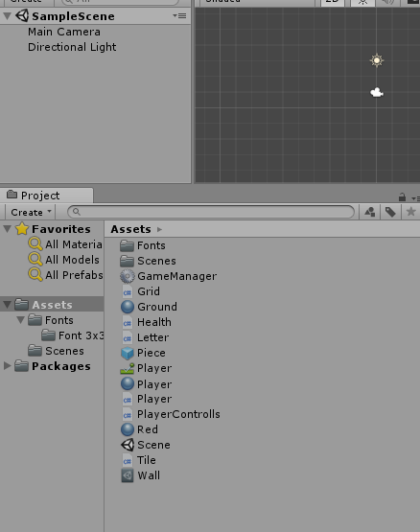

It looks like some assets have gone missing, was nothing when playing, but it has interesting scripts etc. So, it might have been a good idea. Looks like it revolves around typing letters or something, or that it is a game that uses pixelated letters to generate levels or something like that.

Puzzly Colorflip

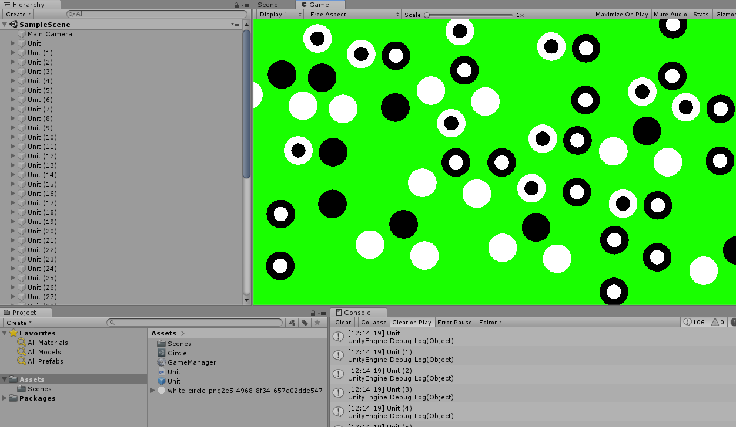

The units are connected in an interesting way, I guess with a radius or something. I think the intention is to make all the same color, and you need to press the units in a strategic order in order for that to happen.

Puzzly Puzzel

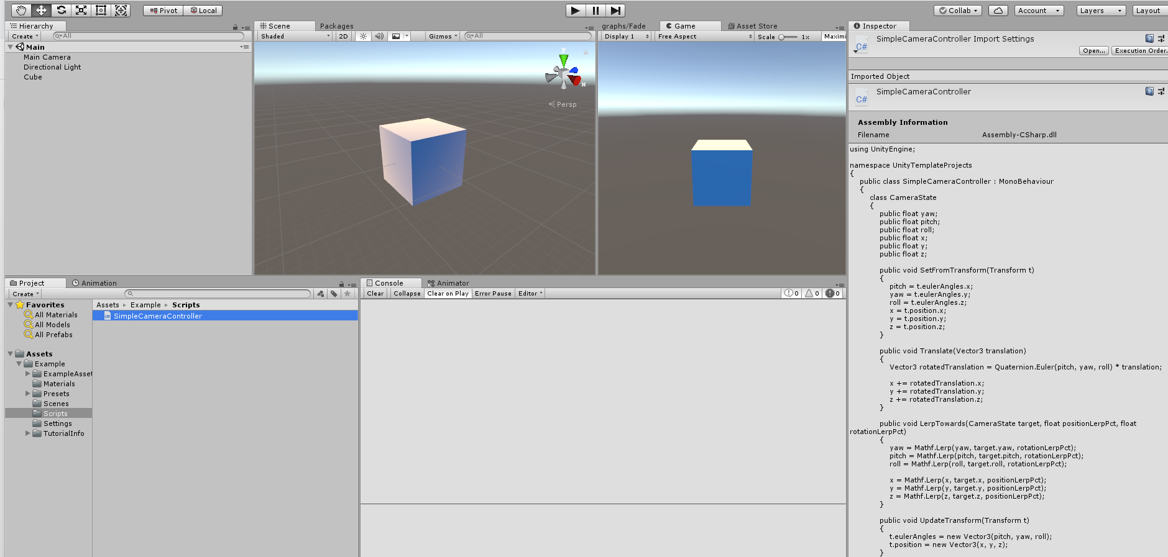

I think this project just tests different assets and things like shaders, but the running game does not seem to do anything specific.

RocketTrail

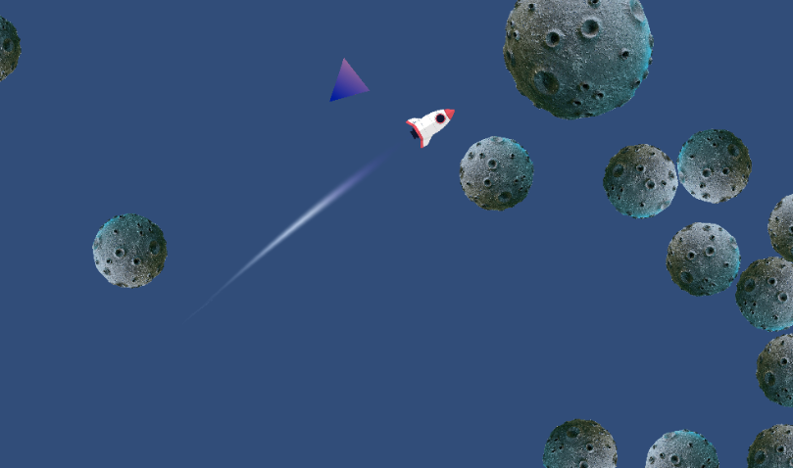

Explores rocket flying physics within Unity. It was developed as an experiment to understand how trails work in the game engine. Though simple, it offers insight into the technical aspects of game development and physics implementation.

RPS.io

Rock paper scissors io is an online game where the objective is to capture the paper if you are the scissors etc. I was not able to start an online match so I could not provide a picture of it.

Salim

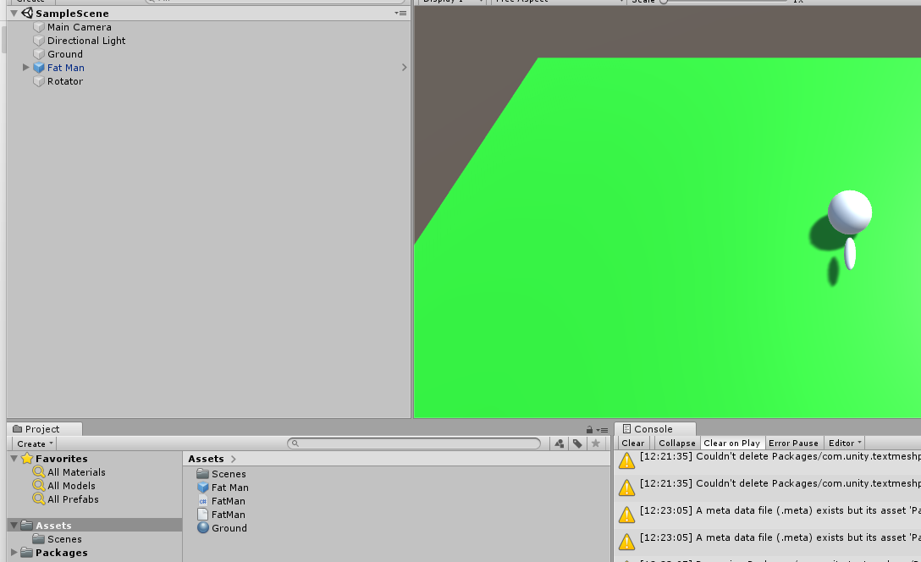

Experiment with camera always looking the player and the player moving around the camera.

Sight

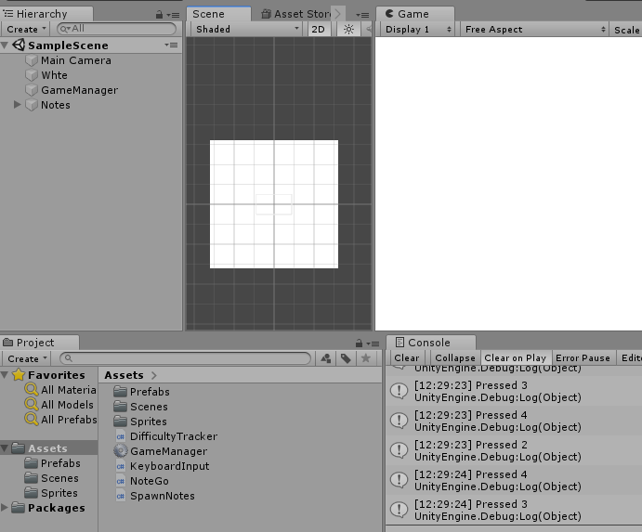

Another experiment on the sightreading program.

Sightreading Program

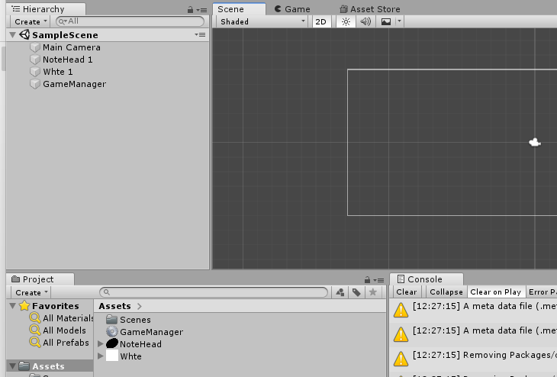

Looks like another experiment of the sightreading program without much implementation.

Simple game 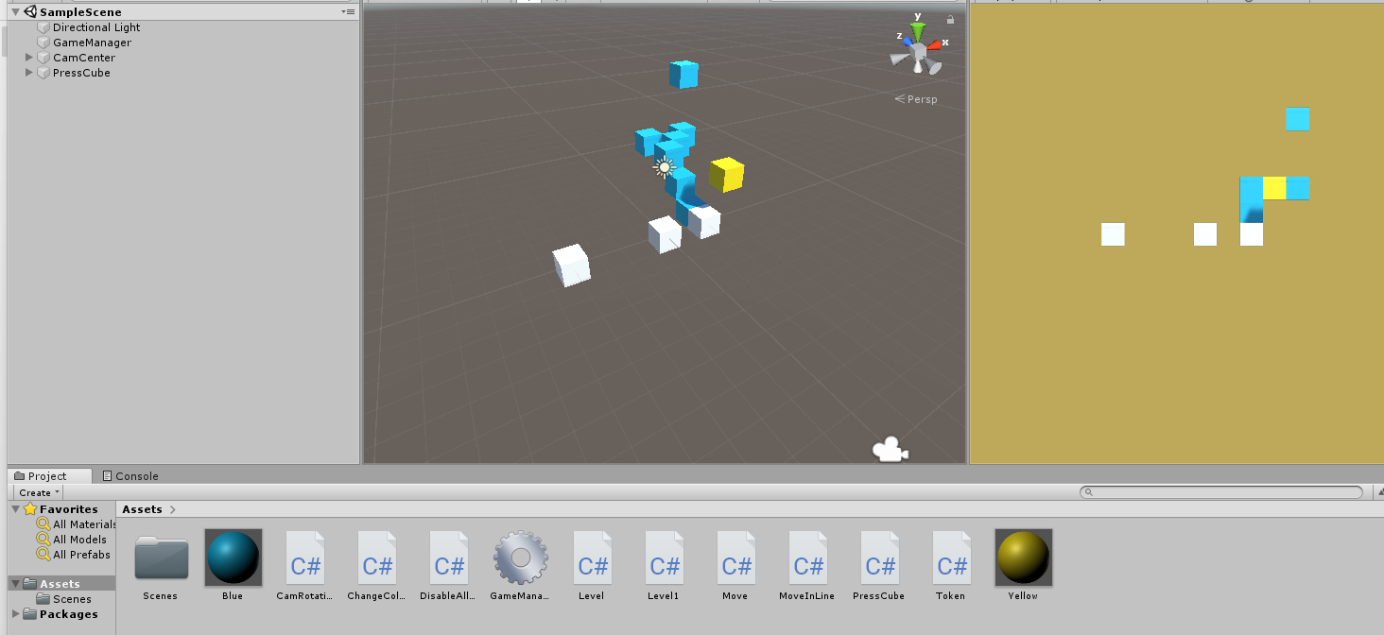

A simple game with folder structure as its core mechanic. All items are connected to new items, and the goal is to reveal all the items. Some things can be moved by the mouse and also moves all attached things, some things has to be pressed to open the folder to see the next thing it is connected to. One thing could rotate all connected things or even the camera.

Simple Game 29.8.22

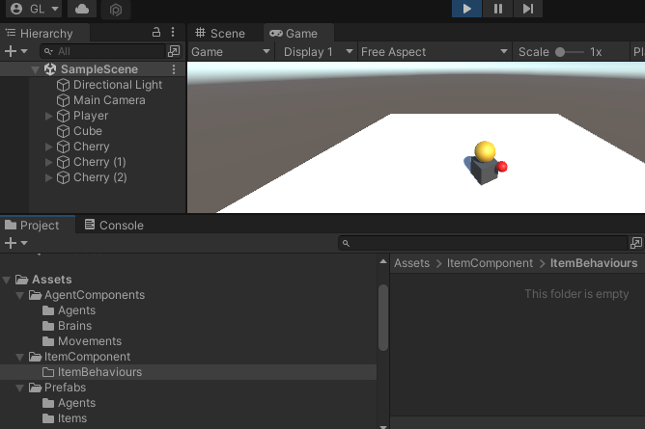

Go around, pick up the red dot.

Simple Game Puzzle

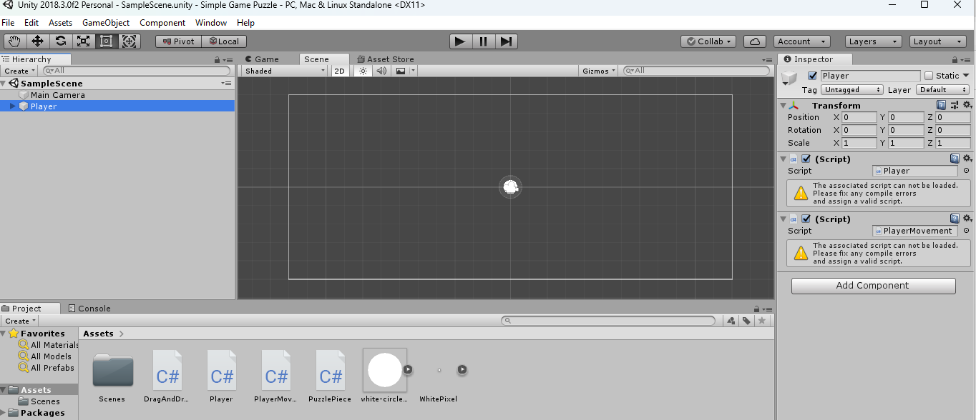

Seems to be an unfinished project with a lot of missing assets and scripts.

Simuleringsteori 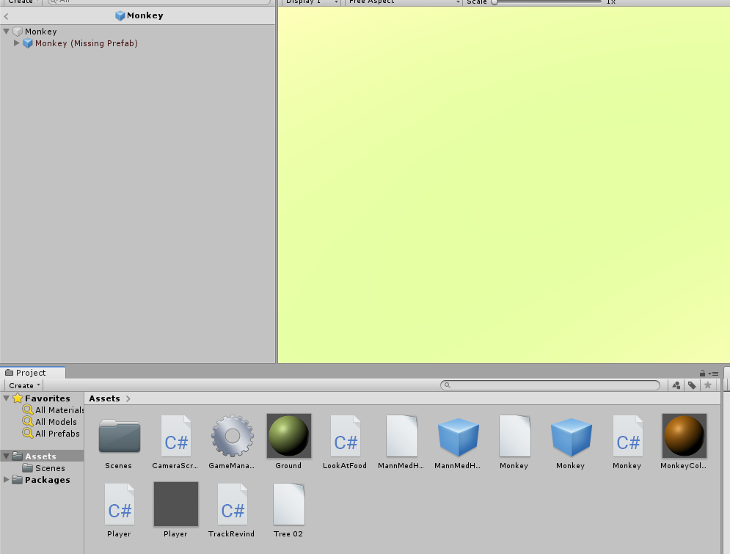

A project made for a subject in high school to demonstrate and present a concept. Some assets seem to be missing and therefore it does not run as expected.

Skilpadde Andakt

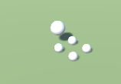

Move the turtle around demonstrating a point. Meshes are missing.

Slektsprogram

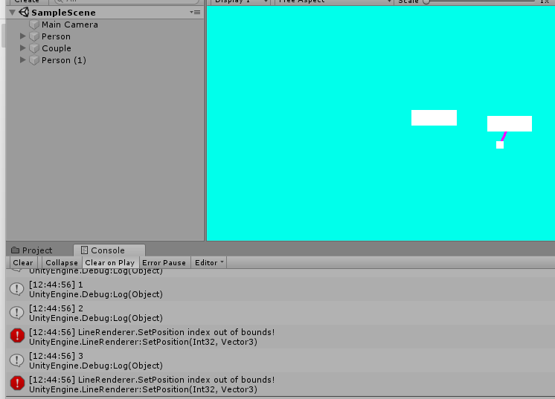

Slottet med rare ting som skjer

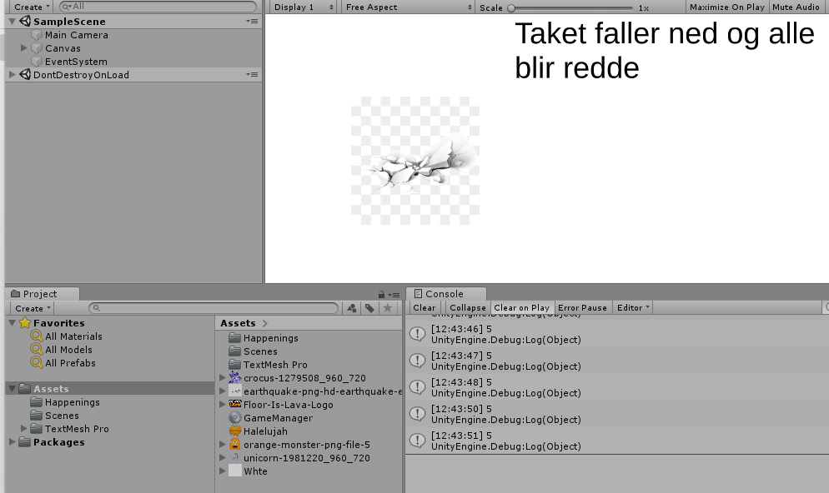

Snake Halvors Request

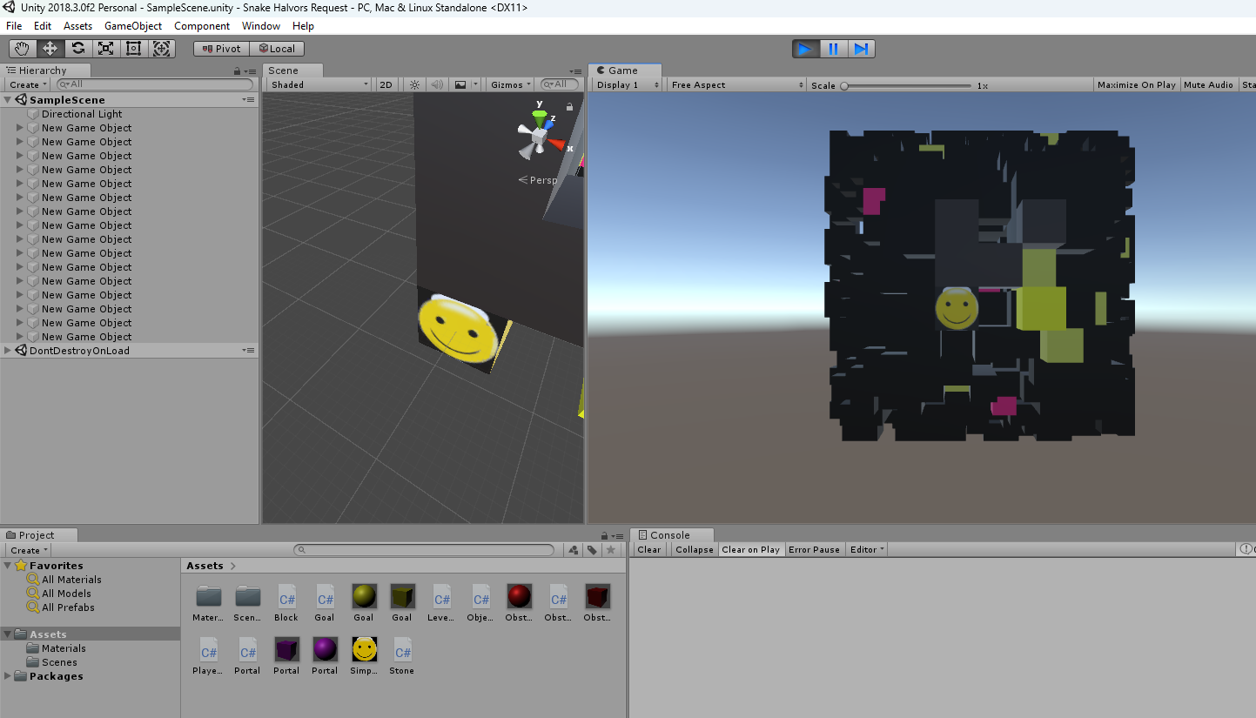

Find the way to the yellow block to go one level deeper each time. I guess the pink blocks might be portals maybe.

SomethingFun

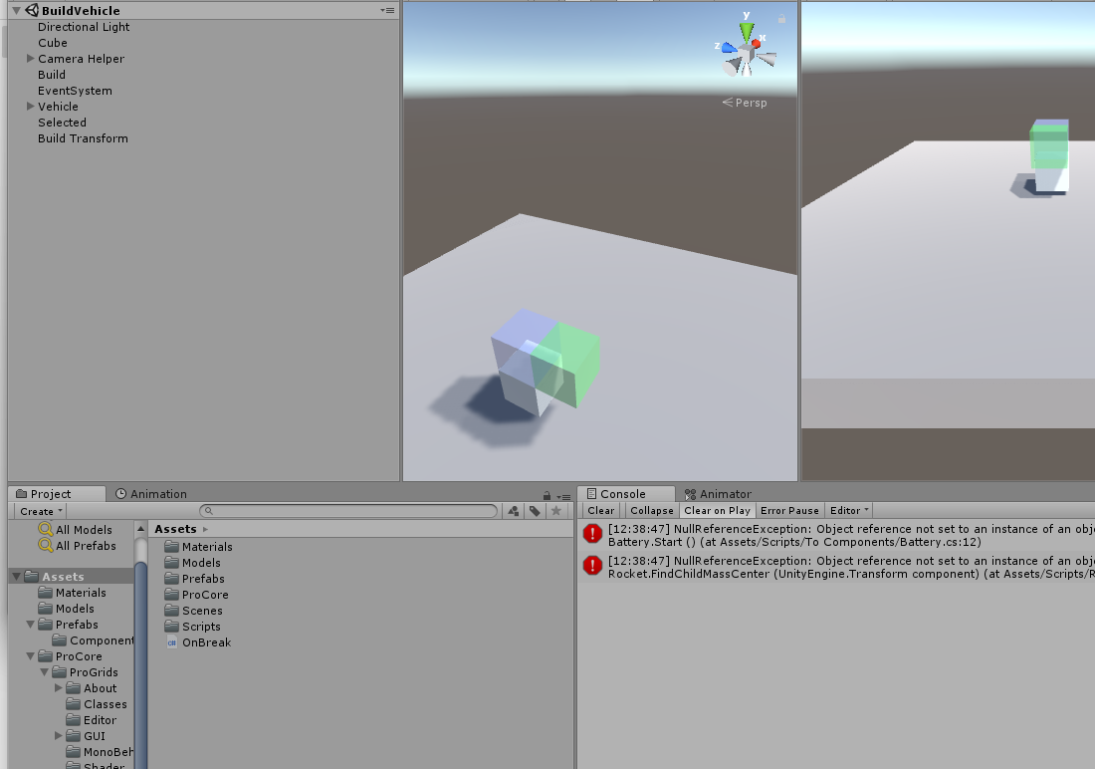

Seems to have some interesting mechanics. I think the aim was to create a game where you could build your own vehicles that could move around and do things. The meshes seem to be missing.

SoulCraft

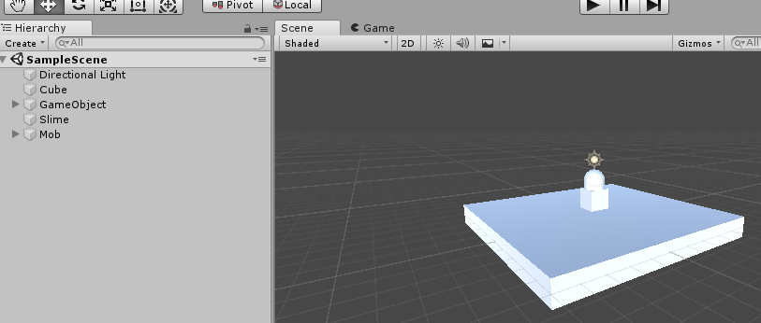

Move around a 1. person character.

SuperItemGameStuff

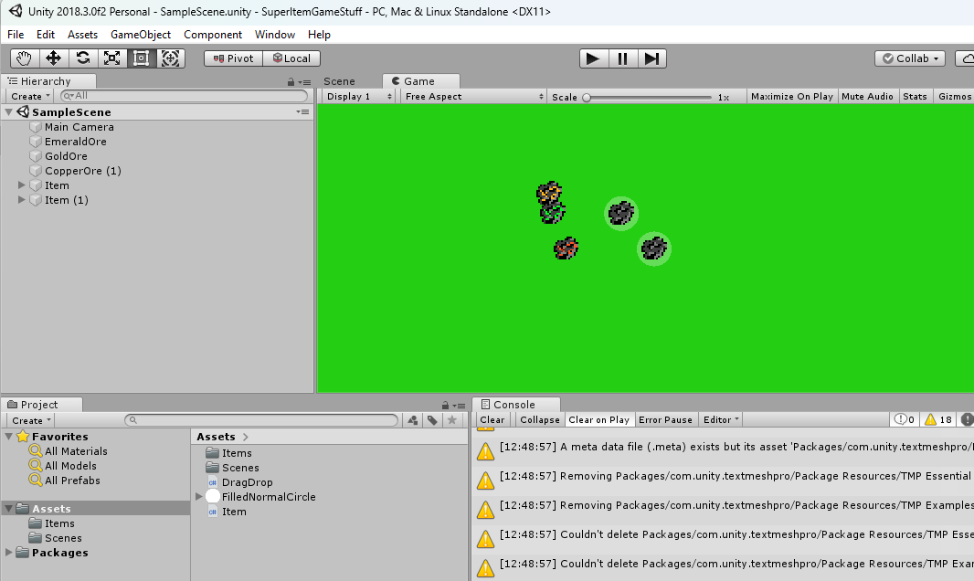

Terramystica Clock

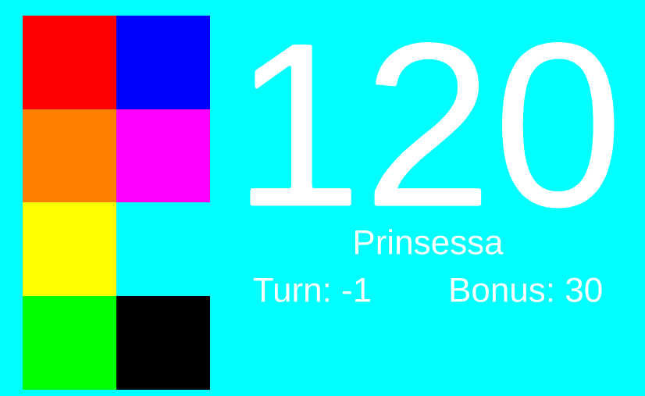

A timer for the Terra Mystica board game.

TheCaveGame

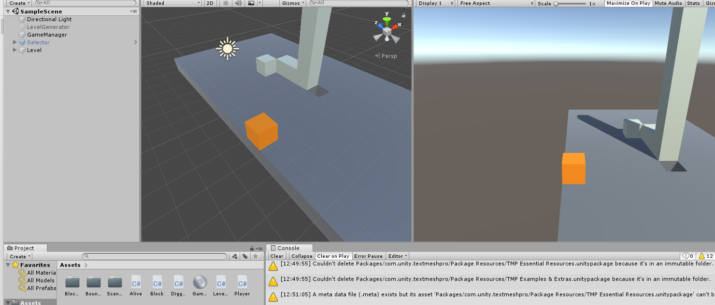

This was a very interesting game, but all the meshes have gone missing, and you can only see parts of it. Each block in the game represents a different mechanical item like an elevator or plumb, and each item interacts with all of the other ones in an interesting way. Inspired by Minecraft and redstone.

TheOnePixelGameWithSounds

A game where you dodge monsters entirely by sound and one pixel of advice on the screen. The whole screen is one color only and each RGB value represent different things like health & monster presence.

TicTacToe

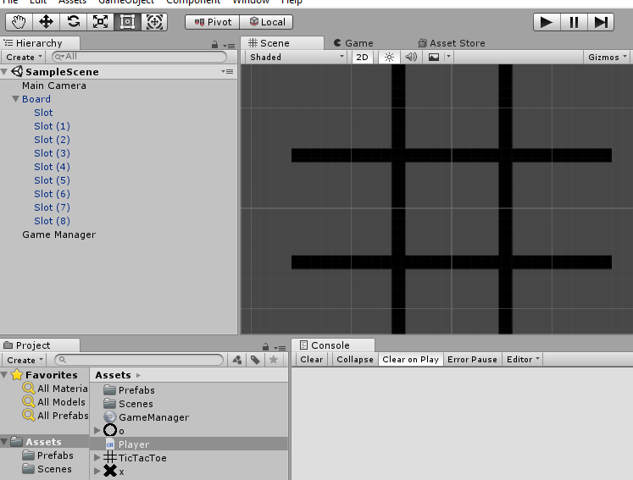

TileGame

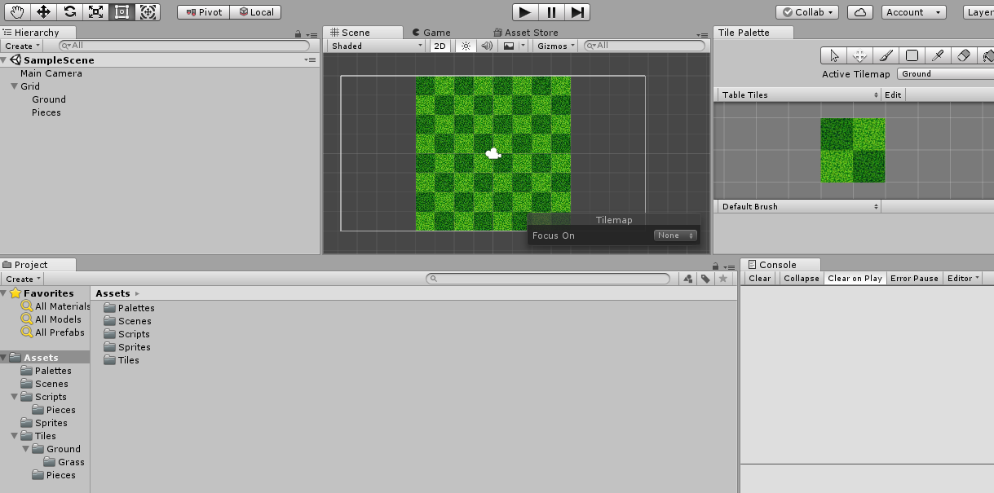

Just messing around with grids in unity.

TileLol

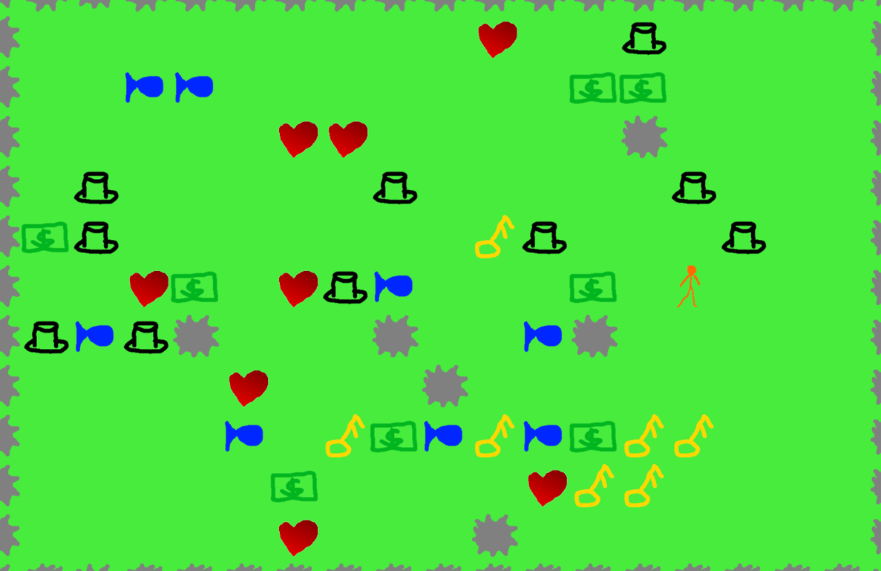

I could not understand the complete intended meaning of the game, but it is about getting the highest score. The orange players are controlled with the arrow keys and are pushing the items around and if you push something on the grey things, they are destroyed.

Timer And Clicker

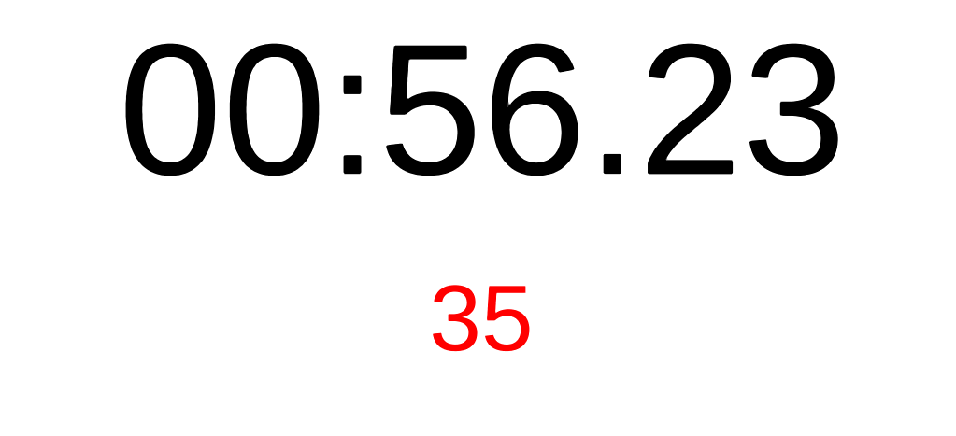

For a competition with my youth group. Press the most times in one minute!

To Music Board Game

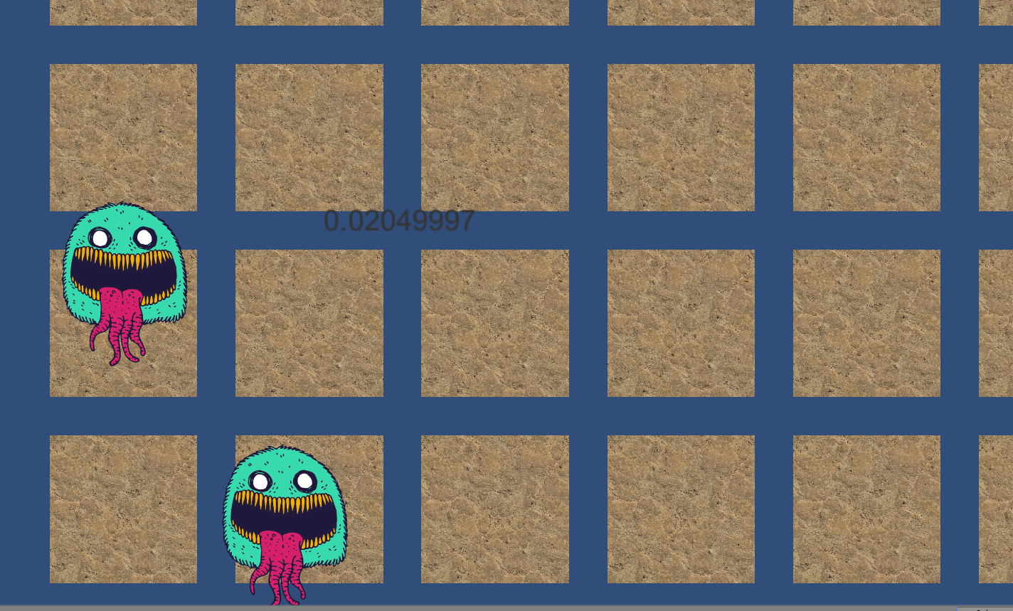  
The monsters moves around like crazy, but I cant remember what the experiment was all about.

Type.io

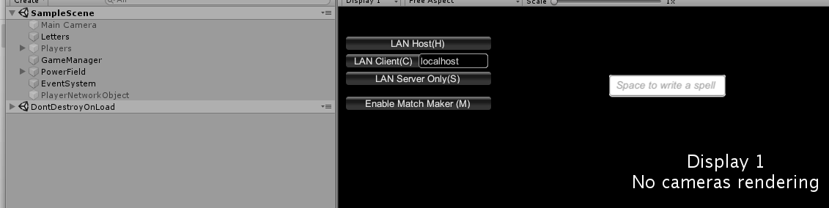

Interesting multiplayer io game where the objective is to write to move, and you want to capture the other players while writing your way there. Was not able to start an online game when testing.

Ubongo Solver

A recursive algorithm to solve Ubongo 3D levels and display them in unity. It did not work as expected.

unity-midi-input-test

A test of a library downloaded from somewhere to have in my sightreading program.